Dear Participant,
Thank you for signing up for the Four County Float through Buena Vista, Cherokee, Clay, and O’Brien counties on the Little Sioux River!
This program was designed to give participants a fun and relaxing atmosphere to socialize and enjoy outdoor activities together. County Naturalists will provide various educational opportunities during the float, should you choose to participate.
Participants may bring their own water vessel (canoe or kayak) or rent one from a county conservation board. The cost to rent one is $10/vessel.
Check-in will begin at 9:00am with a refresher course on Paddling A River offered at 8:30am. Upon arrival participants will need to sign a liability form and pick up an assigned number to be placed on their water vessel. (This helps us keep track of how many water vessels we have in our group.) Depending on water levels and weather, the float could take anywhere from 5-7 hours. Transportation will be available to take people back to their vehicles; however, we will not be transporting personal water vessels.
Below is a list of suggested items to bring on this float:
- Food (lunch and snacks)
- Water, bug spray, hat, and medications (if necessary)
- Towels and extra clothes
- Dry bags for cameras, phones, etc.
- Camping items (for those spending the night)
- Close-toed shoes for enjoying sandbars
- Life jackets (bring one if you have your own water vessel, otherwise one will be provided)
Please fill out and sign the registration form and return it to the Cherokee County Conservation Board office at 629 River Rd, Cherokee, IA 51012. Space is limited and is on a first-come, first-serve basis. Registration is required by everyone before 4:30pm on Tuesday, July 3, 2018. The water vessel rental fee will need to be submitted with registration, if applicable. Make checks payable to Cherokee County Conservation Board. The program will be cancelled due to inclement weather or poor water conditions.
I will be calling or e-mailing to confirm your registration once it’s received. Call 712-225-6709 or e-mail cccblaura@gmail.com with questions.
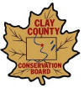
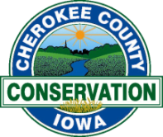
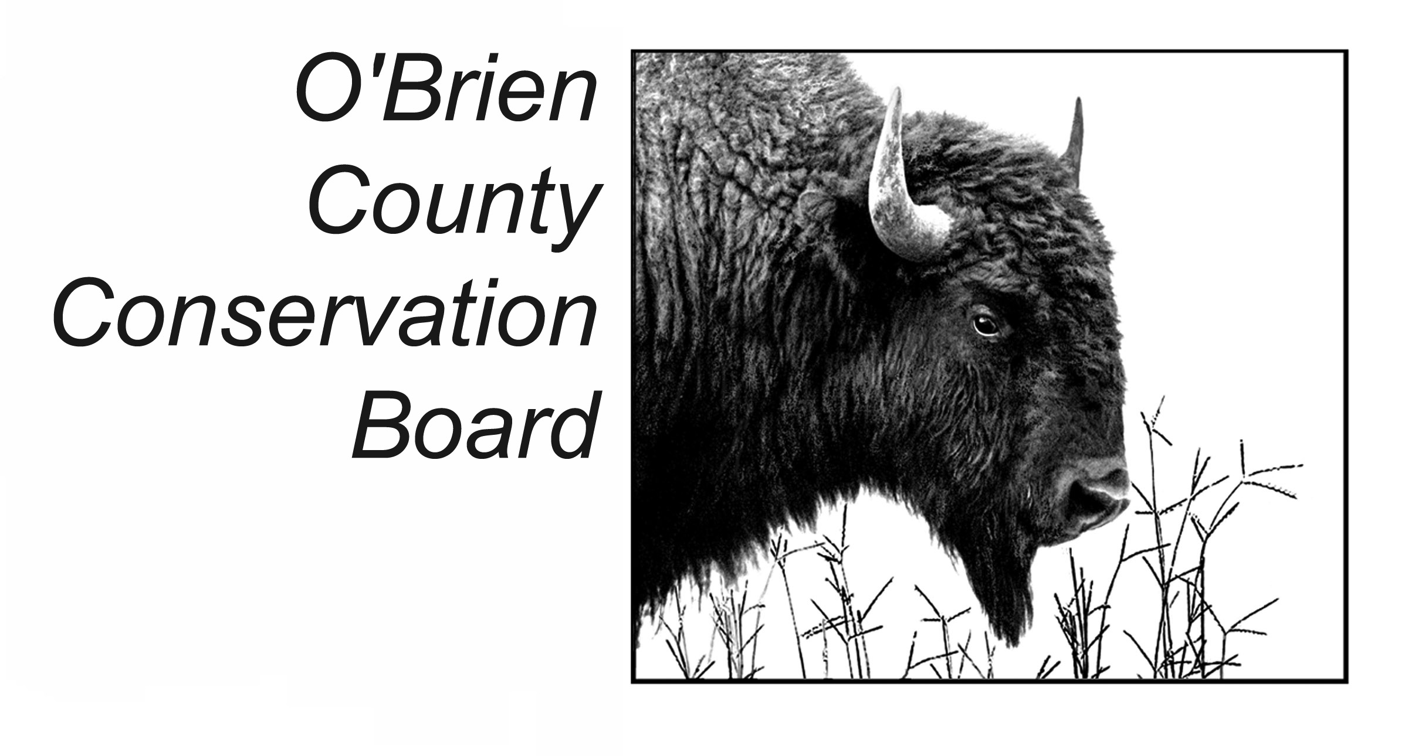
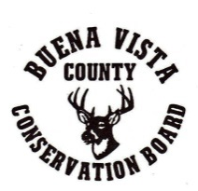
Thank you!

Please fill out a form for each water vessel. Cost is $10/water vessel needed. Fee does not apply to those bringing their own water vessel.
All participants are required to register by 4:30pm on July 3, 2018.
Please return this form to the Cherokee County Conservation Board, 629 River Rd, Cherokee, IA 51012. Call 712-225-6709 or e-mail cccblaura@gmail.com with questions or for more information. Make checks out to the Cherokee County Conservation Board.
Do you need a canoe or kayak?:
☐Yes, I need a canoe (2 adults/canoe) ☐Yes, I need a kayak (1 adult/kayak)
☐No, I have my own water vessel
Contact Person Information:
Name:
Home phone or cellphone #: Click here to enter text.
E-mail Address (Optional: For sign-up confirmation, reminders, and photos):
Click here to enter text.
Names of people in your water vessel : Age (if under 18)
Click here to enter text.
Click here to enter text.
Click here to enter text.
Those under the age of 18 must be accompanied by an adult.
-------------------------------------------------------------------------------------------------------------------------------------------------
Return the above portion by July 3, 2018.
.

